College Explorer Portal
BHEEMREDDY DEVIKA - 2003A52108
VANGARA SAIRAM - 2003A52020
MOHAMMED IBRAHIM AFNAN AHMED - 2003A52013
EPPAKAYALA RISHITH RAJ - 2003A52007
THUMMA PAVAN KUMAR - 2003A52018
Abstract - The project's trying to make a seamless login interface tailored for student, helping the exchange of project codes, films, and academic papers. Deriving inspiration from LinkedIn, this platform allows user to engage in interactions such as liking and commenting on shared content. Through this innovational portal, students are empowered to show their academic tries, ask for feedback, and forge meaningful links within their educational ecosystem. By merging the features of a social network with academic collaboration tools, the project desires to foster a vibrant community conducive to intellectual growth and collaborative learning.
Keywords – Smooth login interface, Academic certificates, LinkedIn functions, Interactions (liking, commenting), Academic tries, Feedback, Social network, Intellectual growth, Collaborative learning
- INTRODUCTION
In the always-changing terrain of education, the integration of technology has become paramount in facilitating dynamic and interactive learning environments. With this vision in mind, we start on the journey to develop a pioneering platform – the College Explorer Portal. This platform acts as a centralized hub where students from diverse academic backgrounds can converge, collaborate, and showcase their edification's tries.
The goal of the College Explorer Portal is to close the gap between academic knowledge and real-world application. Our portal offers students an easy-to-use interface and robust features, enabling them to upload certificates and other study-related documentation in addition to sharing project codes and execution films. This all-encompassing strategy not only improves the educational process but also helps people feel proud of their achievements.

Community-driven learning is at the heart of the College Explorer Portal's philosophy. Students can investigate initiatives and contributions from their fellow comrades through the portal, which promotes a culture of cooperation and knowledge sharing. In addition, activities such as the ability to show contentment through likes and participate in discussions through comments enhance meaningful engagement and strengthen the sense of community among academics.

Drawing inspiration from the success of professional networking sites such as LinkedIn, the College Explorer Portal seeks to give students a same level of visibility and interaction inside their academic communities. The platform serves as a showcase for the skills and accomplishments of its members in addition to facilitating networking by allowing users to create profiles and view those of others.

As we set out on this revolutionary path, the College Explorer Portal aims to reimagine how learners interact with their learning. In addition to meeting the needs of today's learners, our goal is to create a platform that foresees the demands of tomorrow's educational landscape through innovation, teamwork, and a relentless dedication to quality. Come along with us as we embark on this exciting journey to a more promising future in education.

- LITERATURE REVIEW

- Educational Technology and Online Learning Platforms: Talk about how these two areas have evolved and how online learning platforms have become more popular.
Examine how digital tools affect learning results, collaboration, and student involvement.
- Social Networking Platforms in Education: Examine research on the incorporation of social media sites into learning environments.
Analyze the advantages and difficulties of utilizing social media in the classroom.
- Project-Based Cooperation and Education:
Examine studies on the benefits of project-based learning for developing students' critical thinking and problem-solving abilities.
- Examine the function of teamwork in learning environments and how it affects students' academic progress.
- User Interaction and Engagement: Examine theories pertaining to online environments' interaction with users and engagement.
- Examine research on design concepts that improve user experience and engagement in online platform
- Comparable Platforms and Case Studies: - Look at current platforms that are comparable to the College Explorer Portal that has been described.
Examine case studies of effective learning systems, paying particular attention to their features, user interaction, and results.
- Feedback and Assessment methods: - Talk about the value of assessment and feedback methods in learning environments.
Examine studies on the effects of effective feedback techniques on the motivation and learning of students.
- Privacy and Security Considerations: - Talk about privacy and security issues related to online learning environments.
Examine recommended procedures for protecting user information and guaranteeing legal adherence.
- Pedagogical Approaches and Learning Theories: Examine the ideologies of learning and education that guide the creation of instructional materials.
Talk about the applications of constructivist, social, and cognitive theories to online learning environments.
- Impact on Student Learning and Academic Performance: Examine empirical research evaluating how online learning environments affect students' academic performance and learning outcomes.
Talk about the results that pertain to student retention, satisfaction, and engagement.
- Future Directions and Emerging Trends: - Determine the newest developments in online learning and educational technologies.
Talk about possible directions for further study and advancement in the realm of online learning environments.

- The Pandemic Is a Portal(Etta Kralovec, Karina Callejas, Tj Gomez, Hennessey Miller, Clint Lee, Johnyne Blair)

Teachers in a graduate-level education program discuss the unique difficulties they had while teaching during the COVID-19 pandemic in The Pandemic Is a Portal. The article delves into the larger social and political factors that influenced their experiences as teachers during these difficult times. Teachers struggle with imposed policies and procedures that they see as unfair and detrimental to their children in these reflections, and they advocate for more equitable educational methods.

- Understand transfer portal changes so you can avoid common mistakes(Robert Romano J.D., LLM, Delmiro DaSilva)
It's difficult to keep up with everything that's changing in the world of collegiate athletics. One of the largest changes is undoubtedly the transfer portal. If college athletics directors don't continuously keep up with the various adjustments and criteria, it's simple for student-athletes and athletics staff to become confused or make mistakes during the process. Here, we'll provide you with the most recent information available on transfer portals while also providing some advice and thoughts.

- The COVID-19 pandemic: Electronic media use and health among US College students(Robert R Wright , Jordan Larson , Sarah Richards , Shaylee Larson , Christian Nienstedt )
To investigate variations in college students' use of electronic media (TV watching, social media use, screen time), health (physical, behavioral, social, mental), and their interactions with one another prior to and during the COVID-19 epidemic. Participants: A total of 965 college students from the United States participated, 367 of them prior to the pandemic and 598 of them after March 2020. Techniques: Participants filled out an online self-report questionnaire using a multiple cross-sectional design, and for the Pre-COVID group, biometric data was collected in-person. Findings: There was a 14% increase in TV and social media watching time as well as a 30% increase in overall screen time during the pandemic (d =.39). Differences in health were mixed with positive and negative aspects. The majority of the associations between electronic media intake and health-related factors were weaker during the pandemic.

- Self-regulation mediates effects of adapted mindfulness-based stress reduction on anxiety among college students(E L Cary , D Bergen-Cico , S Sinegar , M K A Schutt , E C Helminen , J C Felver)
There is little data to support the mechanistic explanations of the anxiety reduction that mindfulness-based stress reduction (MBSR) provides for undergraduate students. The mechanism of cognitive self-regulation is implicated in theoretical models. This study investigated whether anxiety was decreased by an adapted MBSR integrated into a college course and whether any intervention effects were mediated by self-regulation. Participants: A total of 144 undergraduate students took part in the study; 110 acted as a matched control group, and 34 of them finished an MBSR course. Methods: Before, after, and one month after MBS, anxiety, self-regulation, and mindfulness were assessed.

- Evaluating psychometric determinants of willingness to adopt sexual health patient portal services among black college students: A mixed-methods approach(Kevon-Mark P Jackman , Lisa HightowWeidman , Tonia Poteat , Andrea L Wirtz , Jeremy C Kane , Stefan D Baral )
To determine the correlates of willingness to accept the usage of the electronic personal health record (PHR) and to describe, using mixed-methods, perceptions of access to test results for sexually transmitted infections. Participants: A historically black college in the middle of the Atlantic. Techniques: The usage of PHRs in relation to sexual health was examined through focus groups and interviews (N = 35). Survey measures measuring the beliefs of a cross-sectional sample (N = 354) were operationalized based on the codes. Latent components among survey questions were found using exploratory factor analysis. Correlates of adoption willingness were assessed using multiple logistic regression models. Findings: Three qualitative themes on the relative benefits, obstacles, and functionality of PHRs were identified. The percentage of respondents who were willing to use PHRs for sexual health care was 57.6%.

- Intervening During Incidents of Sexual Assault Among College Student Bystanders(Lucia F. O'Sullivan , Charlene F. Belu , Rice B. Fuller , Morgan E. Richard)
College campuses are still plagued by sexual assault after years of focused response. The focus of recent preventative initiatives has been on how bystanders can lower rates. Just a small amount of research, meanwhile, has looked at actual intervention behaviors rather than intentions to interfere or reasons why people might decide not to assist. An online survey measuring experiences as a bystander observing a sexual assault, readiness to act, helpful conduct, and related beliefs and attitudes (rape myth attitudes, perceived peer norms, perceived self-efficacy) was filled out by 1219 college students, 66% of whom were female. 15% saw something that they thought was a sexual assault in the recent past, and the majority of students (69%) came to the victim's defense.

- Self-regulation mediates effects of adapted mindfulness-based stress reduction on anxiety among college students(E L Cary , D Bergen-Cico, S Sinegar , M K A Schutt , E C Helminen , J C Felver )
There is little data to support the mechanistic explanations of the anxiety reduction that mindfulness-based stress reduction (MBSR) provides for undergraduate students. The mechanism of cognitive self-regulation is implicated in theoretical models. This study investigated if self-regulation mediated any intervention effects and whether anxiety was lessened by an adapted MBSR integrated into a college course. Participants: A total of 144 undergraduate students took part in the study; 110 acted as a matched control group, and 34 of them finished an MBSR course.

- The COVID-19 pandemic: Electronic media use and health among US College students(Robert R Wright, Jordan Larson, Sarah Richards , Shaylee Larson , Christian Nienstedt )
To investigate variations in college students' use of electronic media (TV watching, social media use, screen time), health (physical, behavioral, social, mental), and their interactions with one another prior to and during the COVID-19 epidemic. Participants: A total of 965 college students from the United States participated, 367 of them prior to the pandemic and 598 of them after March 2020. Techniques: An online self-report questionnaire was completed by participants using a multiple cross-sectional design, and for the Pre-COVID group, biometric data was collected in person.

- PROBLEM DEFINITION
Lack of a single platform to interact, share knowledge, and showcase projects presents challenges for students in schools and institutions. For true contact, standard forms of communication such as emails or presentations are insufficient. Students find it difficult to locate accurate information because it is dispersed among several locations. They have trouble keeping things organized and communicating with each other clearly when working on group assignments. Additionally, they receive insufficient credit for their efforts and constructive criticism, which deters them from working as hard. Furthermore, they find it difficult to gather and display their accomplishments, such as diplomas or images pertaining to their coursework. We require an answer that centralizes all the information and facilitates student collaboration.

- PROPOSED METHODOLOGY
A disciplined process will be employed in the creation of the College Explorer Portal to ensure the proper deployment of the platform's functionality, while also resolving potential obstacles and optimizing user happiness. The approach that is being suggested includes multiple crucial phases that are vital for the advancement and final implementation of the platform.

- Requirement Analysis:
As part of our technique, we begin by performing a thorough examination of the College Explorer Portal requirements. This means identifying the precise features and functionalities wanted in the platform by consulting with stakeholders, including as administrators, instructors, and students. User identification, profile management, the ability to publish projects, social interaction elements like liking and commenting, and the capability to view other users' profiles are important factors to take into account. We will obtain information about the tastes and wants of potential users through focus groups, interviews, and surveys to make sure the platform is customized to meet their needs.

- Design Prototyping:
After the requirements are determined, we will move on to the design stage and build prototypes of the user interface (UI) and user experience (UX) for the College Explorer Portal. We will create mock-ups of the login page, project upload interface, profile pages, and social interaction features using wireframing tools and design software. Based on input from stakeholders, these prototypes will be iteratively improved, with an emphasis on usability, intuitiveness, and visual appeal. The objective is to design an aesthetically pleasing and intuitive user interface that promotes interactive engagement and easy navigation.

- Backend Development:
We will start working on the College Explorer Portal's backend development as soon as the design is complete. This entails developing the database management system, application logic, and server-side infrastructure required to enable the operation of the platform. We will build safe user authentication methods, data storage solutions for project uploads and user profiles, and APIs for integrating external services like video hosting sites using contemporary web development frameworks like Django or Ruby on Rails. We will follow best practices in software engineering, such as code modularity, scalability, and security, throughout the development process.

- Frontend Development:
We will work on implementing the College Explorer Portal's frontend components concurrently with the backend development. Writing JavaScript, HTML, and CSS code is part of this process in order to generate the user interface and allow dynamic interactions. From desktop computers to smartphones and tablets, we will make sure the platform is usable on a variety of screens and devices by applying responsive design concepts. We will design a highly interactive and responsive user experience by integrating contemporary frontend frameworks like React or Vue.js, enabling users to interact with the platform's features and explore it with ease.

- Testing and Quality Assurance:
When the College Explorer Portal development is almost finished, we will put it through a thorough testing process to find and fix any bugs, flaws, or usability problems. This will entail both automated testing with programs like Cypress or Selenium and manual testing by our staff of QA engineers. We will conduct compatibility testing to guarantee cross-browser and cross-device compatibility, functional testing to confirm that all features function as intended, and performance testing to evaluate the platform's scalability and responsiveness under load. Furthermore, we plan to ask beta testers who are selected from our target user base for feedback, and we'll take their suggestions into account to further improve the platform before to its official launch.

- Deployment and Launch:
After testing is finished and any necessary improvements are put into place, we will move forward with deploying the College Explorer Portal to a live environment. This include deploying the application code, configuring servers, and setting up the hosting infrastructure. We will automate the deployment process and guarantee stability and scalability by using industry-standard deployment techniques, such as continuous integration and continuous deployment (CI/CD) pipelines. After implementation, we will formally introduce the platform to our intended audience and advertise it via email newsletters, social media, and collaborations with academic institutions, among other avenues.

- Post-launch Monitoring and Iteration:
Our job is far from done even with the College Explorer Portal debut. To discover areas for improvement and refinement, we will regularly evaluate the platform's performance, user engagement data, and user feedback. We can quickly adapt to customer demands and market trends because to our iterative approach to development, which enables us to regularly release updates and new features that keep the platform competitive and current. By keeping the lines of communication open with our user community and encouraging innovation and ongoing development, we make sure that the College Explorer Portal is a useful tool for academic institutions, instructors, and students alike.

- Data Preprocessing
Any platform or program that uses data must first undergo data preparation, and the college explorer site mentioned above is no exception. It entails converting unstructured data into a format that is clear and organized and appropriate for modelling, analysis, and visualization. Within the framework of the college explorer site, data preparation refers to a number of operations meant to guarantee the accuracy, consistency, and usability of the data that users contribute. Let's examine the several phases of this platform's data preprocessing:

- Data Collection:
Gathering data from several sources is the initial stage in the preparation of data. When users upload project codes, execution videos, certificates, and study-related images to the College Explorer Portal, data is gathered. Various formats of text, photos, and videos could be included in this data.
- Data Cleaning:
After the data is gathered, it must be cleaned to get rid of any errors, inconsistencies, or superfluous information. This entails doing things like:
- Eliminating redundant entries: Guaranteeing the uniqueness of every project or user profile.
- Managing missing values: Taking care of any data that is absent from user profiles or submitted files.
- Standardizing data formats: Making sure that uploaded files have the same format (project codes, videos, and photographs, for example).
- Eliminating unnecessary data: Excluding any material that isn't pertinent to the portal's goal.

- Text Preprocessing:
Text preparation is required when working with textual data, including user profiles, comments, and project descriptions. This could include:
- Tokenization is the process of dividing a text into discrete words or units.
- Removing stop words: Getting rid of cliches like "the," "and," and "is" that don't really imply anything.
- Lemmatization, also known as stemming: reducing words to their most basic form to increase uniformity and lessen repetition.
- Managing punctuation and special characters: Adding, deleting, or changing punctuation and special characters.

- Image and Video Processing:
Preprocessing of user-uploaded photos and videos can be necessary to guarantee uniformity and compatibility. This could involve activities like:
- Resizing and cropping: Bringing films and images into compliance with the platform's display specifications by standardizing their proportions.
- Compression: lowering picture and video file sizes to maximize storage and bandwidth utilization.
- Format conversion: Putting pictures and movies into a standard format so they work with a variety of hardware and web browsers.

- Data Integration:
The separate data pieces must be combined into a single dataset after being cleaned and processed. This entails merging data from several sources and making sure that data structures and formats are consistent.
- Data Transformation:
The process of transforming cleaned and integrated data into a format appropriate for modelling, analysis, and visualization is known as data transformation. This could consist of:
- Feature engineering: Using current data, new variables or features are created to improve predictive modelling or analysis.
- Normalization, also known as standardization: Bringing numerical data into line with a shared range to make comparison and analysis easier.
- Encoding categorical variables: Using machine learning methods, categorical variables are translated into numerical representations.

- Data Validation:
To guarantee the pre-processed data's quality, consistency, and integrity, validation is the last step. This entails carrying out tests to confirm that the information satisfies the quality requirements needed to be used in the college explorer portal. Before continuing, any inconsistencies or abnormalities found during validation should be fixed.
These procedures can be used to preprocess the data gathered by the college explorer site, guaranteeing its quality and suitability for the platform's intended uses. Enabling relevant analysis, simplifying user interactions, and providing a seamless portal experience all depend on effective data pretreatment.
- Features of the College Explorer Portal:
A number of tools are available on the College Explorer Portal that are intended to improve student cooperation and knowledge exchange. A secure login page allows users to visit the portal and create accounts. They can upload project codes, execution videos, credentials, and other study-related documents after logging in. Other users can interact with the content by liking posts and posting comments after they can see these submissions. Every user has a profile on the portal, which enables them to connect with peers and display their work.

- User Engagement and Interaction:
Encouraging meaningful student interactions is one of the College Explorer Portal's main goals. We hope to build a dynamic atmosphere where users can express their happiness with projects and have fruitful conversations by introducing tools like liking and commenting. In order to promote a feeling of community and teamwork within the portal, this interactive feature is essential.

- Project Collaboration and Feedback:
Students can present their work and get comments from their peers by uploading project codes and execution videos. Enhancing learning outcomes and honing project abilities require this feedback loop. Users can ask questions, get clarification, and make suggestions using the comment section, which encourages cooperation and knowledge exchange.

- User Profiles and Networking:
Every user on the College Explorer Portal has a unique profile where they can highlight their accomplishments, abilities, and projects. Students can showcase their abilities and interact with other like-minded students using these accounts, which function as a digital portfolio. Through the integration of networking capabilities akin to those found on LinkedIn, the portal serves to foster professional relationships and chances for mentorship among academic communities.

- Security and Privacy Measures:
It is crucial to protect user data's privacy and security. Strong authentication procedures are in place on the College Explorer Portal to protect user accounts and private data. Users may also manage who can see their uploads and profile details thanks to the user privacy settings, which gives them piece of mind when using the platform.

- Future Developments and Expansion:
We want to add more features and functionalities to the College Explorer Portal as it develops in order to better serve the changing needs of educators and students. Potential future advancements could involve the incorporation of enhanced collaboration tools, industry alliances, and virtual networking events. We want to establish the site as a pillar of contemporary education, enabling students to prosper in a world that is changing quickly, and we do this by remaining sensitive to user feedback and new trends.

- RESULT
The project described in the abstract aims to provide a login experience that is student-focused and facilitates the exchange of academic diplomas, project codes, and films. The platform, which was inspired by LinkedIn's features, lets users engage by commenting and like information that has been published. Encouraging students to present their academic work, ask for criticism, and form relationships with other members of their school community is the aim. The initiative intends to establish a stimulating atmosphere for intellectual development and cooperative learning by fusing social networking characteristics with academic collaboration capabilities.

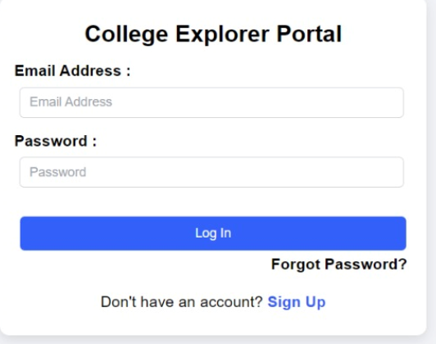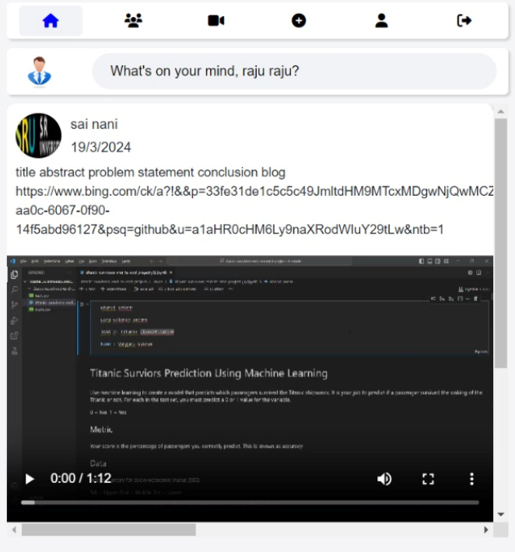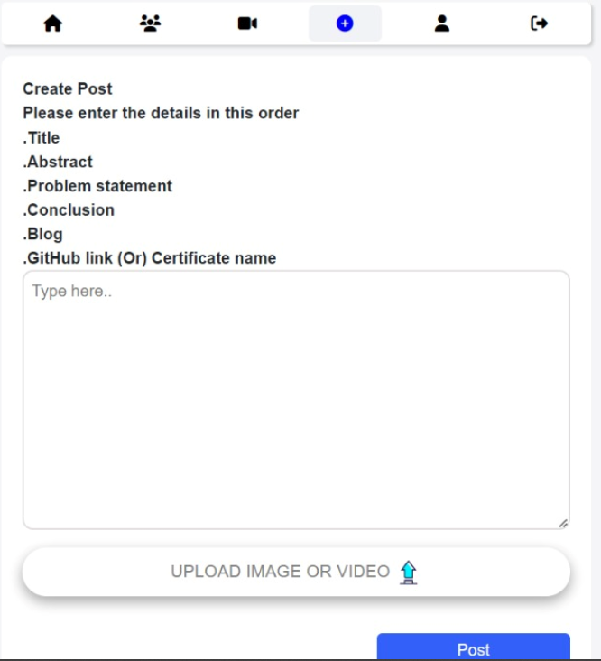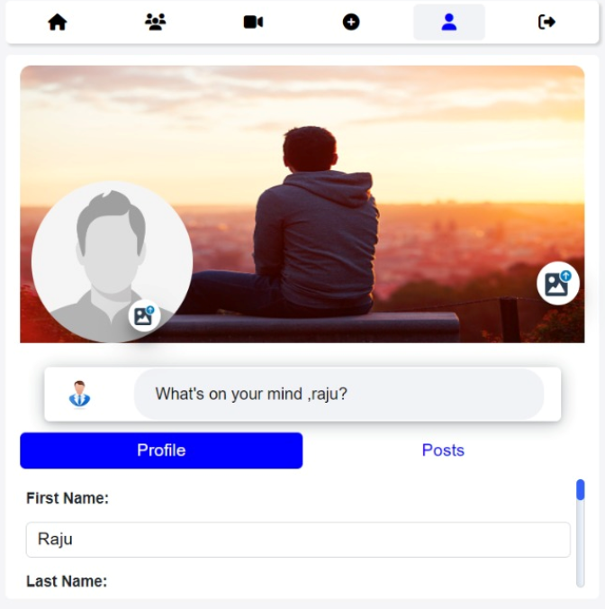

- CONCLUSION
Within educational institutions, cooperation, participation, and knowledge exchange are being greatly enhanced by the College Explorer Portal. The portal gives students a central location to share projects and engage in social interaction. This allows them to exhibit their work, network with classmates, and develop the kind of skills necessary to succeed in the digital age. The portal will continue to be at the forefront of educational innovation as long as it is refined and iterated based on user feedback. An overview of the College Explorer Portal, including information on its features, development process, and possible educational impact, has been presented in this paper. Platforms such as the College Explorer Portal are essential for improving collaborative learning and equipping students for the challenges of the future, especially as technology continues to change the face of education.

- REFERENCES
https://www.knack.com/blog/create-a-student-portal/
https://dribbble.com/tags/college-portal

https://www.researchgate.net/publication/372149990_Design_and_development_of_an_Online_College_Portal_for_effective_information_management
https://www.manageengine.com/products/service-desk/self-service/build-self-service-portal.html

https://www.netventure.in/college-website-design/
https://morweb.org/post/college-websites

https://www.academia.edu/4083326/A_proposed_Web_Portal_for_the_College_of_Computing_and_Information_Technology

https://www.proquest.com/openview/6d39038abf6802c174b0c9fe1130e801/1?pq-origsite=gscholar&cbl=18750

https://eluminoustechnologies.com/blog/education-portal-development-guide/
https://www.c-sharpcorner.com/article/creating-a-simple-login-page-using-html-and-css/

https://www.codingnepalweb.com/website-login-registration-form-html-css-javascript/

https://medium.com/swlh/how-to-create-your-first-login-page-with-html-css-and-javascript-602dd71144f1

https://www.codewithfaraz.com/article/126/30-login-form-collection-with-source-code-in-html-css-and-javascript

